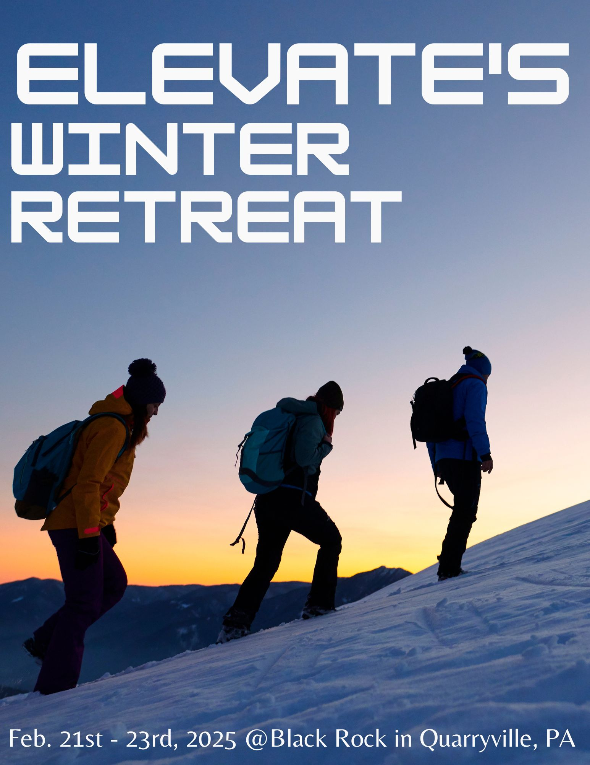
ELEVATE’S WINTER RETREAT 2025
STUDENT AGREEMENT

To be able to attend Elevate’s Winter Retreat I understand that:

I must participate in the cookie walk fundraiser on Sunday,
December 15^{th.}
I must frequently attend Elevate youth group on Wednesday nights (At least twice a month).

As a student attending Elevate’s Winter Retreat I understand that I will follow these expectations:

No negativity
Respect adult leaders and fellow students
Respect the staff and property of Black Rock Retreat Center
Pick up after myself
Remain in my cabin after lights out
Girls will not be allowed in boys cabins and boys will not be allowed in girls cabins
Respect quiet hours (10pm-7am)
No pranks
No Purple-ing (Public display of affection)
Participate and encourage others to do so
Be where I am supposed to be when I am supposed to be there
Expect God to do great things this weekend
Phone use will only be permitted during free time and any adult has the right to ask for a students phone.

Student Signature:________________________________

Date:______________

ELEVATE STUDENTS MINISTRY’S
WINTER RETREAT 2025

WHERE: Black Rock
Quarryville, PA
If you would like to see what it is like check out their website: www.blackrockretreat.com

WHEN: February 21st -23rd
Meet @ the church Friday, February 21st @ 4:15pm
We will be back Sunday, February 23rd around 3:00pm

COST: $165
Deposit of $50 due by December 15th (If this does not work contact P. Caleb)
Final payment due by February 2nd
This covers ALL of your expenses for the weekend.
You can bring spending money for the retreat store.

FUNDRAISER: There will be a cookie walk fundraiser Sunday, December 15, 2024 to raise funds toward the cost of Winter Retreat.

THE LEADERS:

Pastor Caleb Lynch (717)825-3822 Pastor.Caleb@laurelnazarene.org
Sarah Donohoe (302)381-1835 semills04@gmail.com
Pastor Ryan Hollis (302)381-7207 Pastor.ryan@laurelnazarene.org
Marci Hollis (302) 841-0265‬
Laurel Nazarene Church
Parental Consent, Certification, and Medical Authorizations for the year of 2025
Parents and legal guardians of minors are asked to complete this form and return it to the Youth Department. The information requested is intended to assist the church in providing for the safety of minors during church-sponsored activities for one full year calendar . (This form also covers the transportation of students on our Wednesday night weekly activities if there are events off of the campus of Laurel Nazarene Church.)
Please print:
Teen’s Name:________________________________ Date of birth:_________________ T-Shirt Size_________
Teen’s Address:_____________________________________ City: ______________ State/Zip:________________
Caretaker #1’s Name:________________________________ Relationship:______________________________
Caretaker #1’s Cell Phone:____________________ Work/Home Phone:__________________________
Caretaker #1’s Email:______________________________________ List as Emergency Contact?: (Circle) Y / N

Caretaker #2’s Name:________________________________ Relationship:_____________________________
Caretaker #2’s Cell Phone:_____________________ Work/Home Phone:_________________________________
Caretaker #2’s Email:______________________________________ List as Emergency Contact?: (Circle) Y / N

Medical Information/Special Instructions:
List student’s allergies to drugs, food, etc.:______________________________________________________________________
List any medication taken regularly:_______________________________________________________________
Does your student have any preexisting medical conditions?
Please explain: _______________________________________________________________________________
____________________________________________________________________________________________
Would any of these conditions prevent your student from participating in certain rigorous activities?
Please explain: ________________________________________________________________________________
_____________________________________________________________________________________________
_____________________________________________________________________________________________

Can your child swim? (Circle) Y / N

Are you comfortable with your student riding in other student’s vehicles to meet for a church sponsored event? (Example: Meeting at a Dairy Queen but church vans are not providing transportation and another student offer your child a ride in their vehicle) If so, please say “yes” or “no”:________________________

If yes, are there certain students/families you are comfortable having your teen ride with? Please specify or say
“any”:________________________________________________________________________________________

Other special instructions about your student: ________________________________________________________
_____________________________________________________________________________________________
_____________________________________________________________________________________________
Medical Release

I, _____________________________, the parent/legal guardian of _____________________ or legally responsible adult participant, hereby consent to the participation of myself/my child in all of the activities of the Youth Ministries at Laurel Nazarene Church for the duration of the 2025 calendar year, including field trips/outings, camp, mission trips, swimming, boating, hiking, sporting events, and any other activities customarily associated with a church’s ministry. Furthermore, I/we certify that I myself/my child am/is physically fit and adequately trained to participate in such events. I/We also authorize Laurel Nazarene Church and its staff members or volunteers to consent for any necessary medical treatment should I/we be unavailable to authorize said treatment. I/We agree to be financially responsible for any charges incurred for the necessary treatment of myself/my child. I/We do understand that adult supervision reserves the right to restrict myself/my child from any activities that they do not feel is within the physical capacities of myself/my child.

Guardian’s/Legal Adult’s Signature: ________________________________Date: ___________

Transportation Release

Should it become necessary for myself/my child to ride in a Laurel Nazarene Church vehicle, a staff member’s vehicle, or volunteer’s vehicle, or should it become necessary for myself/my child to ride in another teenager’s vehicle with the preferences and permission concerning this on the previous page (No child/teenager will ride with another child/teenager as they or their family drive their vehicle unless specified and given permission on previous page), I do hereby agree to hold the staff member, volunteer, and Laurel Nazarene Church harmless of any liability arising from any injury, accident, or damage, and release and further discharge Laurel Nazarene Church and its staff and volunteers, and its respective successors, heirs, assigns, agents, officers, directors, shareholders and servants, and all other persons, firms and corporations, from any injury, accident, or damage whatsoever caused to any person, firm, or corporation, from and against all loss, reasonable counsel fees, expenses, and liabilities incurred on or about any such claim, action or proceedings brought thereon, which I/we may now have or hereinafter assert against Laurel Nazarene Church and/or its staff or volunteers with respect to my child’s riding in the church’s, staff’s, or volunteer’s vehicle, or arise from any injury, accident, or damage whatsoever cause to any person, firm, or corporation.

Guardian’s/Legal Adult’s Signature: ________________________________Date: ___________

Social Media/Internet Release

I give Laurel Nazarene Church permission to allow pictures taken of myself/my child to be taken for the purpose of contact information records and for the commemoration of various church activities. I also give Laurel Nazarene Church permission for these pictures to be posted on this church’s website, on this church’s social media accounts, and during this church’s services for the purpose of commemorating various church activities.

Guardian’s/Legal Adult’s Signature: ________________________________Date: ___________

